MQ SERIES INTERFACE DOCUMENTATION

Version 5.0

Dated: 2/14/99

******* DRAFT *******
Table of Contents

INTRODUCTION 5
TECHNICAL INTRODUCTION 5
ESTABLISHMENT OF QUEUES 7
Introduction 7
Standard Queues 7
How to Request Queue Set-up 8
OBTAINING MQ SERIES CLIENT FOR WINDOWS 95 8
Introduction 8
Guidelines for Using MQ Series Client 8
Request for MQ Series Client 8
SAP INTERFACE DESIGN 9
Introduction 9
SAP Inbound Interfaces 9
SAP Outbound Interfaces 9
High-Level SAP Outbound Schematic & Assumptions 10
USE OF COMMON MQ SERIES “PUT” ROUTINES 11
Introduction 11
“PUT” Routine Alternatives 11
Supported Platforms 11
Known Restrictions 11
Using the Total “PUT” Solution 12
Introduction 12
Inputs 13
Data File Format 13
Control Totals File Format 13
Parameter File Format 14
Sample Parameter File 15
Processing Logic Contained within the Common “PUT” Modules 16
Outputs 16
Locating the Common “PUT” Executables 17
Examples of Using the Common “PUT” Solution 17
Using the Common “PUT” Module 17
USE OF COMMON MQ SERIES “GET” ROUTINES 18
Introduction 18
“GET” Routine Alternatives 18
Supported Platforms 18
How to Use the Total “GET” Solution 19
Introduction 19
General Design Assumptions 19
Inputs and Outputs 20
Inputs 21
Parameter File Format 21
Outputs 22
Locating the Common “GET” Executables 22
Examples of Using the Common “GET” Solution 23
Using the Common “GET” Module 23
APPLICATION SPECIFIC MQ SERIES ERROR PROCESSING 23
Introduction 23
High-Level Error Processing Schematic 24
How to Use Common Error Processing Routines 24
UNDELIVERED (Dead Letter) MESSAGE PROCESSING 25
Introduction 25
High-Level Undelivered Message Schematic 25
How to Use the Undelivered Message Process 26
Introduction 26
General Design Assumptions 26
Inputs and Outputs 27
Inputs 27
Parameter File Format 27
Outputs 28
Locating the Common “DLQ” Executables 28
Examples of Using the Common “DLQ” Solution 28
MESSAGE CONFIRMATION PROCESSING 29
Introduction 29
High-Level Confirmation Message Schematic 29
How to Use the Confirmation Message Process 29
Appendices 30
Appendix A - MQ Series Roles & Responsibilities 30
Appendix B - Change Management Process & Procedures for Common Routines 31
Introduction 31
Change Management Guiding Principles 31
Change Management Procedures 33
Change Request Initiation 33
Purpose 33
Prerequisites 33
Procedures 33
Preliminary Impact Analysis 34
Purpose 34
Prerequisites 34
Procedures 34
Detailed Impact Analysis 35
Purpose 35
Prerequisites 35
Procedures 35
Consolidation/Notification 36
Purpose 36
Prerequisites 36
Procedures 36
Approval 37
Purpose 37
Prerequisites 37
Procedures 37
Appendix C - MQ Series Common Routine Errors 38
Appendix D – ISO Central Dead Letter Queue Process 40
Appendix E – Request for MQ Series Development/Test Queues 41
Appendix F – “PUT” Solution: MQ Series Windows 95 Client Interface Example 43
Appendix G – “PUT” Solution: MQ Series NT Interface Example 46
Appendix H – “PUT” Solution: MQ Series AIX Interface Example 46
Appendix I – “PUT” Solution: MQ Series Mainframe Interface Example 47
Technical Background 47
Calling Conventions 47
Installation Prerequisites 47
Quick Reference 48
Annotated Sample 49
Dataset Listing 52
Development Datasets: 52
Development Testing Datasets: 52
Acceptance Testing Datasets: 52
File Interface Datasets 52
Programming Interface Datasets 52
File Interface Datasets 52
Programming Interface Datasets 52
Job Control Language (JCL) 53
Job Control Parameters 55
Sample Output 55
Appendix J – Sample “GET” Parameter File 56
Appendix K – Sample DLQ Parameter File 57
Appendix L - Sample Log Files 58
Log File from Successful Run 58
Log File from a Failed Run 59

INTRODUCTION

This document is intended to provide detailed information on the MQ Series common routines built and maintained by ADSS. These routines were originally built to satisfy the requirements of Project Infinity and the interface of legacy systems to SAP. While the documentation references SAP specifically, it is possible to use these routines for other than interfacing with SAP.

The audience of this document is any developer who has a need to utilize MQ Series and may be able to utilize these routines to minimize their development and maintenance effort and to ensure standardization across all systems utilizing MQ Series. It is assumed that the reader of this document has a basic understanding of MQ Series.

TECHNICAL INTRODUCTION

In the current application to application interface model in the ATE segment of the Technology Architecture, there are two key technologies referenced: MQ Series and MQ Series Integrator. There are two diagrams provided below to help depict the recommended usage of these two technologies. The content of these two diagrams is as follows:

- Technical schematic showing the TCCC specific high-level technical architecture of MQ Series and MQ Integrator
- Technical schematic showing the TCCC specific solution model of MQ Series and MQ Integrator.
A technical schematic showing the solution model of MQ Series and MQ Integrator specific to TCCC
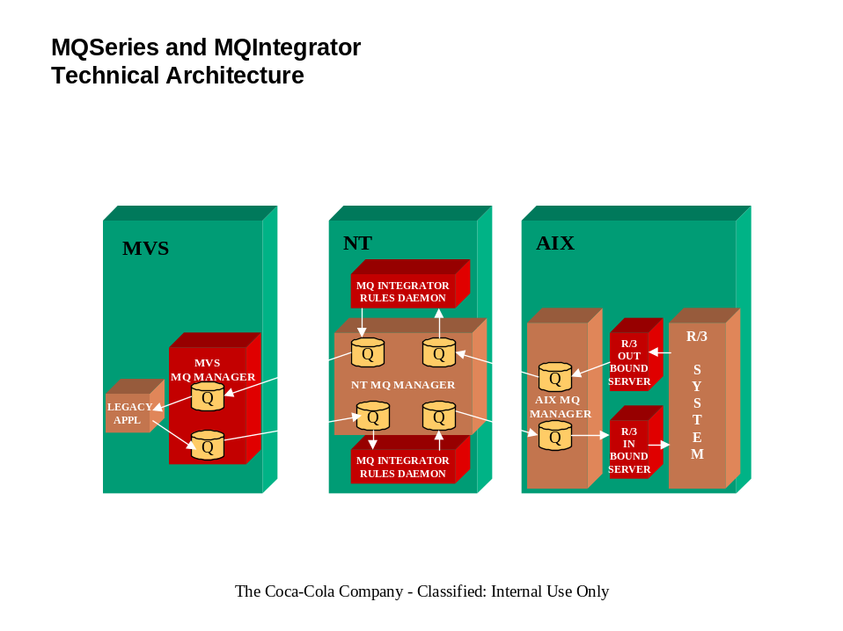

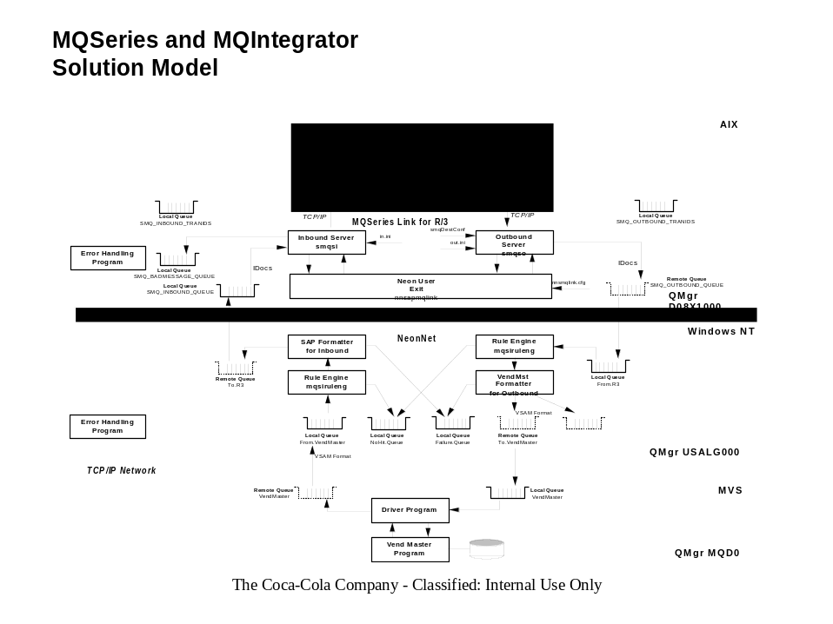As shown in the diagram, it is necessary to have objects known as MQ Series queues defined in order to utilize MQ Series and/or MQ Series Integrator. A queue is an object that is the a storage facility for the messages that are to be sent or received by another application have very similar COMMIT and ROLLBACK logic as a database. These queue objects are setup by ISO. Refer to the next section for procedures on how to request queue definitions.

ESTABLISHMENT OF QUEUES

Introduction
The purpose of this section is to describe the standard queues that can be used by each application team utilizing MQ Series, to pass information between applications. The procedure for requesting queue set-up is also provided.

Standard Queues
For applications sending information to SAP, the following queues are recommended:

- Application Specific Data Queue
- Application Specific Dead Letter Queue
- Application Specific Error Queue
- Application Specific Reply Queue
- One Central, Shared Control Totals Queue per Platform (NOTE: This is a requirement from Project Infinity)

For applications sending information to any application other than SAP, the following queues are recommended:

- Application Specific Data Queue
- Application Specific Dead Letter Queue
- Application Specific Error Queue
- Application Specific Reply Queue
- Application Specific Control Totals Queue

The purpose of each queue listed above is as follows:

- Application Specific Data Queue
Contains the data messages being sent to the recipient application.

- Application Specific Dead Letter Queue
Contains all data messages that cannot be delivered. The ISO Central Dead Letter Queue Process is used to populate this queue. Refer to Appendix D for specifics on this process.

- Application Specific Error Queue
Contains all application specific errors that are not captured by MQ Series and placed in the Central Dead Letter Queue.

- Application Specific Reply Queue
Contains all replies sent by the recipient application.

- Control Totals Queue
Contains control totals, by interface, to assist the receiving application in determining whether a complete data transmission has been received.

Contact a coach from ADSS for assistance if you are unsure of the need for these standard queues, or believe you need to deviate from the standard. The coach will help you to determine whether a variation from the standard set-up is warranted.

If a project team is unsure of the need for these standard queues or believes they need to deviate from the standard, a coach from ADSS should be contacted to assist in determining whether a variation from the standard set-up is warranted.

How to Request Queue Set-up

There are three landscapes that can be set up for MQ Series. They are:

- Development
- Test
- Production

To request setup of MQ Series Development and Test queues, complete the request form and return it via e-mail to Blair Belton. Once received, the anticipated turnaround time for the request is three to five days. A copy of the Request for MQ Series Development and Test queues form is attached in Appendix E of this document.

The set-up/move to a production environment is a separate process. Until a formal process can be defined, send a request via e-mail to Blair Belton, requesting a production setup. Attach the original development and test queue setup request, in order to provide critical queue information needed to ensure compatibility between test and production.

OBTAINING MQ SERIES CLIENT FOR WINDOWS 95

Introduction
The purpose of this section is to describe the process for obtaining the MQ Series Client for Windows 95 software.

Guidelines for Using MQ Series Client
If the sending or receiving application is PC based, the MQ Series Client option might be appropriate. More complete guidelines will be available in this document in a future release. In the meantime, if further guidance is needed to assess the fit of using MQ Series Client, contact an ADSS coach for assistance.

Request for MQ Series Client
Until a formal process is defined, follow the steps listed below:

- Determine if the application is suitable for a Windows 95 workstation MQ Series client approach. If assistance is needed, Paul Smith, custodian of ATE segment of the Technology Architecture, or an ADSS coach should be contacted.

- If the application is suitable, send an email to Dawit Bizuwork of UBAS, with a copy to Blair Belton, requesting the software be installed. Allow three to five days turnaround.

SAP INTERFACE DESIGN

Introduction
This section provides information on the design for the interface between SAP and ISS legacy systems. Where documents already exist, a reference to those documents is included in this section, rather than repeating the information.

SAP Inbound Interfaces
The requirements and specifications for the SAP Inbound interfaces are defined and maintained by Project Infinity personnel. Documentation of these requirements and specifications can be found in the IS Infinity Align Doc Library, in Lotus Notes.

High-Level SAP Inbound Schematic 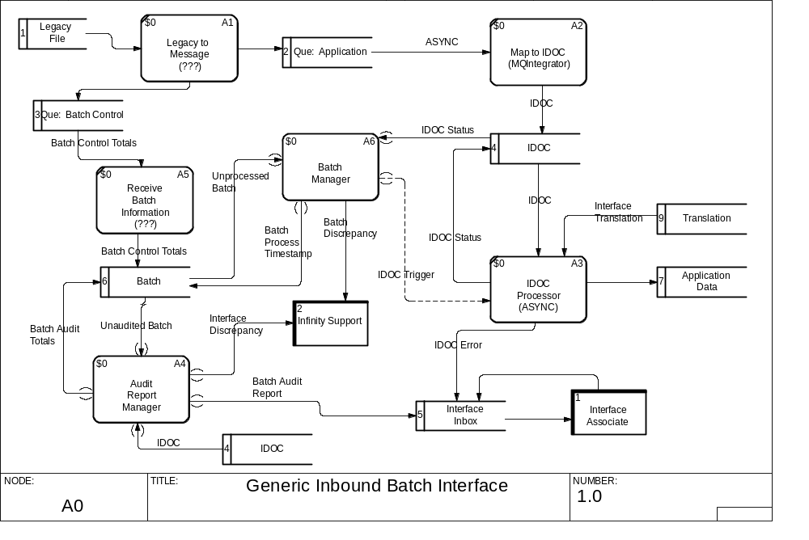

SAP Outbound Interfaces
The requirements and specifications for the SAP Outbound interfaces are defined and maintained by the personnel responsible for the legacy applications that are to receive the information. These specifications are currently being defined. As they become available, they will be added to the IS Infinity Align Doc Library in Lotus Notes.

High-Level SAP Outbound Schematic & Assumptions
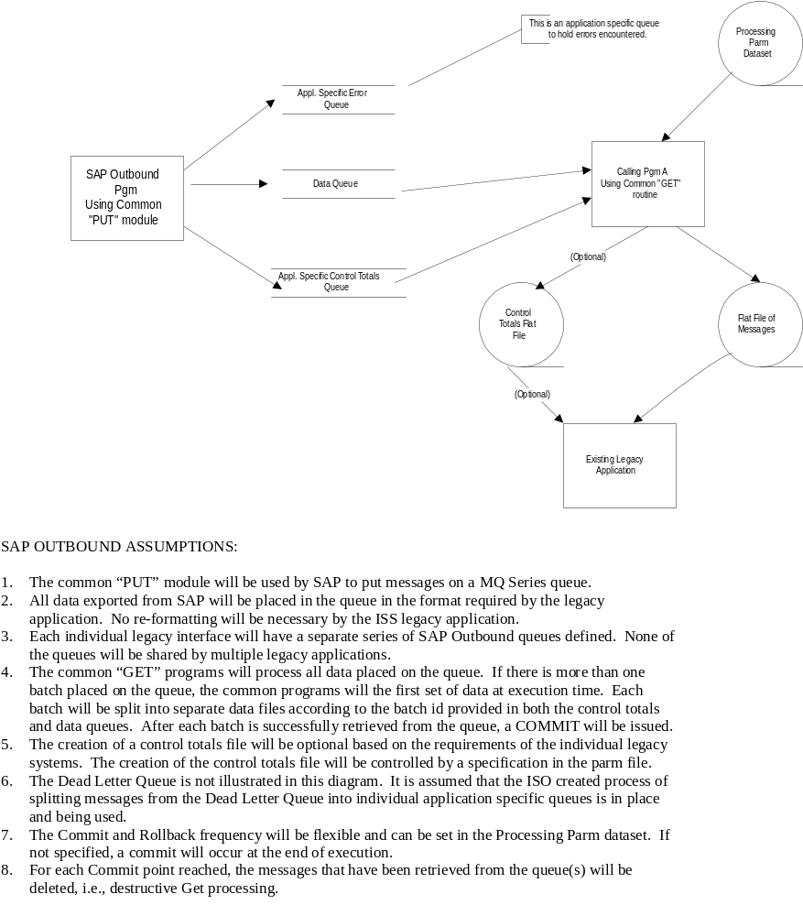

USE OF COMMON MQ SERIES “PUT” ROUTINES

Introduction
The purpose of this section is to describe the various alternatives for using the centrally created and This section describes the alternatives available for using centrally created and maintained MQ Series “PUT” wrapper routines. Additionally, information is provided, for each alternative, on how to interface with these routines, to insolate all applications from having to fully understand how to interact with the MQ Series software.

“PUT” Routine Alternatives
TCCC has developed a series of centralized MQ Series “PUT” interface modules. There are two different ways to use these modules, depending on the requirements of the sending application:

- Use the total “PUT” solution
This alternative takes a flat file of messages as input, and translates the flat file into an MQ Series Data Queue by using a data set of parameters to control the process. The application must also provide a Control Totals flat file, for this alternative to translate into an MQ Series Control Total Queue.

- Use the common “PUT” interface module
This alternative is a callable module and/or series of functions to perform the actual MQ Series commands needed to accomplish putting a message on a queue. The calling program may be written in any language that supports calling a C++ or Cobol executable.

Supported Platforms
Both alternatives are available on NT, AIX, MVS, and Windows 95 client. The interface modules are written in C++ for the NT platform, AIX platform, and Windows 95 client. Cobol was used to write the MVS interface modules. Currently the NT, Windows 95 client, and MVS versions of the total PUT solution are available for use. Sandy Beem in ADSS should be contacted for first time users of the common routines.

The common interface routines will be available for the AS/400 in the first half of 1999. The callable modules are currently being ported and tested on the AS/400 as part of a USA Fountain initiative.

Known Restrictions
- When using the MQ Series for Windows 95 client software, only one connection to a single MQ Series Server can be made. However, many queues can be opened on that server, and each queue may be configured to send a message to many other MQ Series queues on many other MQ Series servers.

Using the Total “PUT” Solution

Introduction

The program read 3 input files, a parameter file, an application data file, and a control file. The parameter filename is passed to the program as a command line option. The parameter file is read to determine additional operating parameters, such as queue manager names, queue names, and input and output filenames. Data read from the application data file is placed, record by record, on the specified interface data queue. Each record corresponds to one message placed on the queue. Once all application data is processed, the data from the control file is placed on the specified interface control queue. The program’s activity is logged in the specified log file.

Although not pictured, the program also writes information to a specified restart file. If interim commits are required before the process completes, the program records how many records it committed. If an error occurs, the program can be rerun using a special "restart" switch. In "restart" mode, the program reads the restart information, reads the input file past the last commit point, and resumes where it left off.

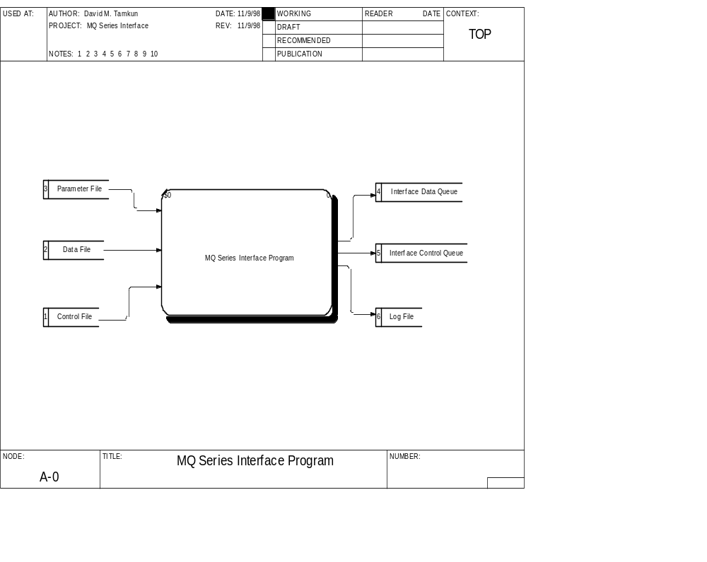

It is assumed this solution will be utilized in a batch-mode.

Inputs

This program reads a… | To…
Data File | Get application data for placement on the Application Data Queue. Each record in the file becomes one MQ Series message.
Control Totals File | Get the job control data for placement on the Control Queue. Examples of control data include the total number of records (messages) in the data file, as well as certain field totals for auditing and data feed verification.  This file should contain a single record. Like the data file, each input record corresponds to one message that is put on the queue.
Parameter File | Get job and operational values, such as the Queue and Queue Manager Name, to connect to the maximum number of messages to place on a queue before doing a commit, etc.  Records/messages up to 4MB in length are permitted.
Restart File | Determines which record was the last committed and what Message ID was used for the previous batch. With this information, the program can continue where it left off.

Data File Format
The common “PUT” routines contain no business or re-formatting logic. The data will be placed on the queue exactly as it is provided. Therefore, it is important that data files provided as input be formatted to specification. .

Control Totals File Format
The common “PUT” routines contain no business or re-formatting logic. The data will be placed on the queue exactly as it is provided. Therefore, it is important that control files provided as input be formatted to specification..

Parameter File Format
The parameter file contains named parameters and their values. An equal sign, “=,” separates the parameter name from the value. Lines beginning with a semi-colon, “;” may contain comments, and are ignored.

The parameter file contains the following parameters:

QMgrName | The name of the Queue Manager to connect to.  This must be an alphanumeric value of no more than 48 characters and is required.
DataQueueName | The name of the queue receiving application data.  This must be an alphanumeric value of no more than 48 characters and is required.
ControlQueueName | The name of the queue receiving batch control information.  This must be an alphanumeric value of no more than 48 characters and is required.
ReplyToQName | The name of the queue that should receive replies from SAP. MQ Integrator uses this name to derive the application's error queue.  This must be an alphanumeric value of no more than 48 characters and is required.
ErrorQueueName | The name of the queue that should receive errors from MQ Integrator or this Put program.  This must be an alphanumeric value of no more than 48 characters and is required.
BatchInterval | Specifies the maximum number of Puts that can be placed on a queue before the program should issue a COMMIT. Ideally, Puts should not be committed until the entire batch has been placed on the queue. However, if the data feed is large enough, this may not be practical. The precise value will depend on the size of each message and the configuration of the application’s queue .  This must be a numeric, non-negative value.  A value of 0 indicates that Commits should not be performed until all messages are placed on the output queues. NOTE: A maximum of 4,000 is permitted.  If this value is greater than zero, the RestartFileName is required.
BufferSize | Indicates how large a buffer should be allocated for reading input data. This value should be larger than the record length for either input file.  This must be a numeric value between 2 and 4194305 and is required. NOTE: A maximum size of 1 MB is permitted.
ExpirationInterval | Represents how many tenths of a second a message can remain on a queue before it should be flushed from the system.  This must be a numeric value > 0.
MsgID | Used to indicate which Interface the message data is a part of, as well as a date and time stamp representing the time period of the data. This is used to identify an entire batch of data uniquely. This value is placed in the MsgID field of every message.  Refer to the Project Infinity Inbound Batch Interface Design document for the use and format of this parameter. Additionally, the common “PUT” module appends a date and time stamp to the end of the MsgId provided, to ensure uniqueness.  This must be an alphanumeric value of no more than 10 characters, and is required. With the addition of the date and time stamp, this field will be 24 characters in length.
LogFileName | Represents the name of the output file used to log status and error information. If the file exists, it will be overwritten.  Errors that occur before the error queue is open will be captured in this file. Errors that occur after the error queue is open will be placed on the error queue.  This must be an alphanumeric value, representing a legal filename, and is required.
DataFileName | Represents the name of the input file containing application data for placement on the Interface Data Queue.  This must be an alphanumeric value, representing a legal filename, and is required.
ControlFileName | Represents the name of the input file containing control information corresponding to the application data. This control information is placed on the Interface Control Queue.  This must be an alphanumeric value, representing a legal filename and is required.
RestartFileName | Represents the name of the file used to write or receive synchpoint information. If interim commits are required, i.e. the Batch Interval is non-zero, the program records the number of messages committed after each commit point.  If the program is run in "restart" mode, the program reads this file to determine where it left off. It then resumes processing after the last successful commit, completing a failed batch.  Note that this is required if the Batch Interval is greater than zero.

Sample Parameter File

;
; MQ Series SAP Inbound Interface Program Parameter File
;
QMgrName=USALG000
DataQueueName=USTCCCAA.INTERFACE.DEV
ControlQueueName=USTCCCAA.INTERFACE.DEV2
ReplyToQName=USTCCCAA.INTERFACE.DEV3
ErrorQueueName=USTCCAA.xxx.ERR
;
; Batch Interval represents the maximum number of Puts that can be placed on a queue
; before the program should issue a COMMIT. Ideally, Puts should not be committed
; until the entire batch has been placed on the queue. However, if the data feed
; is large enough, this may not be practical. The precise value will depend on the
; size of each message and how the application's queue is configured.
;
BatchInterval=0
;
; Expiration Interval should be a number from 1 to ?? that represents how
; many tenths of a second a message can remain on a queue before it
; should be flushed from the system.
;
ExpirationInterval=1000
;
; The Message ID field is used to indicate the Interface the message data is a part of as
; well as a date timestamp representing the time period of the data. This is used to
; uniquely identify an entire batch of data. This value is placed in the MsgID field
; of every message.
;
MsgID=DEVTEST890
;
LogFileName=log.txt
DataFileName=datasmall.txt
ControlFileName=control.txt
;
; The Buffer Size must be; plus one byte for a terminating NULL character. large enough receive the longest record in your data file
The maximum buffer size
; supported is 4194305, which is 4MB plus 1 byte.
;
BufferSize=32767
;BufferSize=4194305
;
; The Restart File contains the number of records committed at each interim commit.
; When run in Restart Mode, the program reads this file to determine where it left
; off and what the Message ID was for the previous batch.
RestartFileName=restart.txt

Processing Logic Contained within the Common “PUT” Modules
While the common “PUT” modules do not contain any specific business logic, there is some processing logic contained within these modules that is pertinent to anyone using the modules.

- As stated earlier, the MsgId provided is appended with a date and time stamp, to ensure uniqueness across batches of messages. The format of the date timestamp is YYYYMMDDHHMMSS.
- All data records are assigned a sequence number within the message header, before placing the data on an MQ Series queue. The Control Totals message is assigned the last sequence number within the batch, to ensure that all messages have been received. This sequence number is placed in the CorrelId field of the message header.

Outputs
- Application Specific Data Queue – application data from the data file is placed record-by-record on the Interface Data Queue. Each record in the put file becomes one message on the queue.

- Control Totals Queue – Once all application data is placed on the queue, the first record of the control file is placed on the control queue.

- Log File - application errors encountered before the error queue is open are captured in this log file.

- Application Error Queue - application errors that occur after the error queue is open are placed on the application specific error queue.

- Restart File - Each commit point is logged to the restart file, allowing the program to continue resume processing where it left off, if necessary.

Locating the Common “PUT” Executables
To be documented in a future release of this document.

Examples of Using the Common “PUT” Solution
In order to assist first time users of these modules, examples for each of the supported platforms have been included in the appendix. The individual examples are located as follows:

Appendix F - “PUT” Solution: MQ Series Windows 95 Client Interface Example

Appendix G - “PUT” Solution: MQ Series NT Interface Example

Appendix F - “PUT” Solution: MQ Series AIX Interface Example

Appendix F - “PUT” Solution: MQ Series Mainframe Interface Example

Appendix L – Sample Log Files

Using the Common “PUT” Module
To be documented in a future release of this document.

USE OF COMMON MQ SERIES “GET” ROUTINES

Introduction
This section describes the various alternatives for using the centrally created and maintained MQ Series “GET” wrapper routines. Additionally, information is provided on how to interface with these routines to insulate all applications from having to fully understand how to interact with the MQ Series software.

“GET” Routine Alternatives
TCCC has developed a series of centralized MQ Series “GET” interface modules. There are two different ways to use these modules, depending on the requirements of the receiving application:

1. Use the total “GET” solution
This alternative takes an MQ Series Data Queue as input, and translates it into a flat file, by using a data set of parameters to control the process. An MQ Series Control Total Queue is also translated into a flat file. This provides a mechanism for legacy applications to receive information from other applications, without requiring in-depth knowledge of MQ Series.

2. Use the common “GET” interface module
This alternative is a callable module, and/or series of functions, to perform the MQ Series commands necessary to retrieve a message from a queue. The calling program can be written in any language that supports calling a C++ or Cobol executable.

Supported Platforms
Both alternatives are available on NT, AIX, MVS, and Windows 95 client. The interface modules are written in C++ for the NT platform, AIX platform, and Windows 95 client. Cobol was used to write the MVS interface modules.

The common interface routines will be available for the AS/400 in the first half of 1999.

How to Use the Total “GET” Solution

Introduction

The KO MQ Series Get Program is designed to exercise a common KO developed “wrapper” to the MQ Series API. The program gets data messages off a data queue and writes the message data to the specified file. The program can be used as an interim solution for application development teams needing to receive data from SAP to feed a legacy system.

Due to its generic nature, this program does not contain business logic. Data must be preformatted according to its interface specification. Each record in the input file must correspond to a single message to be placed on a queue.

General Design Assumptions

- This program does not contain business logic. It gets message data off the queue and writes it to the specified output file as-is, without reformatting or translation.

- This program receives data from only 2 queues, an application data queue, and a batch control queue. It is assumed each control message corresponds to a group of data messages.

- This program operates on only 1 batch of data at a time. The program must be run multiple times to process multiple batches. Unless a different or modified parameter file is used for each run, the program will always write output data to the same files, overwriting any previous contents.

- This program only supports the “single record per message” output data format. Each message is written as one line of data to the output file.

- The program is designed to work with string format data. The message data cannot contain binary or packed data. For the MVS/AS400 version, the SAP R/3 Link format is also supported.

- The Message ID and Correlation ID of the data and control messages are assumed to follow the protocol established by the PUT program.

- The Message ID field always contains printable characters, not binary or packed data.

- The Message ID of the control message exactly matches the Message ID of the corresponding data messages.

- The Correlation ID of the data message always contains character representations of numeric digits.

- The Correlation ID of the first data message is always the string "000000000000000000000001". The second data message should have a Correlation ID of "000000000000000000000002", etc.

- The Correlation ID of subsequent messages is always incremented by 1.

- For the MVS/AS400 version of the routines, the following assumptions apply:
- The output file attributes are established in by specifying either “Dynamic” or “Static” with a default value of “Dynamic” used. The meaning of these values is as follows:
- STATIC: The file attributes assigned at file allocation time are used. Note: Use of this option mandates that the data control block (DCB) is preset with these attributes when the file is allocated. Failure to adhere to this requirement will result in abnormal terminations (ABENDS) during open processing of the output dataset with a system return code of S013-34.
- DYNAMIC: The initial message in the data queue is used to establish the logical record length and the subsequent block size of the output file.
- Keywords are not case sensitive.
- Keyword use embedded hyphens (-) to separate words.
- Any text that is not a valid keyword is treated as a comment.

- For the non-MVS/AS400 version of the routines, the following assumptions apply:
- The Record Length for Control File will always be no more than the record length of the data input file.
- The Record Length for the Application Data File will always be no more the maximum message size established by ISO. Currently, this limit is 2,093,152 bytes.
- This program will only run on the Win32 environment and on AIX.

- These routines do not address Database Connectivity or coordinating Message Queue Activity with Database Activity.

- It is assumed implicit Commits and Rollbacks of the MQ Series are sufficient to handle abnormal program termination or Queue Manager Disconnects without explicit commits or rollbacks. Assuming additional code in our KO API is not necessary.

- This default behavior differs by platform and must be considered in future iterations and platform ports.

- On NT and AIX, if a program disconnects from a Queue Manager with work pending, without doing a commit or rollback, MQ Series performs an implicit Commit.

- On NT and AIX, if a program terminates without disconnecting from the Queue Manager while work is pending, MQ Series performs an implicit Rollback, assuming the program terminated abnormally.

Inputs and Outputs

The program reads a parameter file to determine certain operational values, such as the Queue Manager Name, the Queue Names, the Output File Names, etc. The parameter filename is passed to the program as a command line option. If the program is run in "restart" mode, it reads a restart parameter file to determine what it already wrote to the output file so it can resume processing where it left off.

The program browses the specified control queue and examines the data in the first message it retrieves to determine an expected message count. Next the program retrieves corresponding data messages off the data queue, matching the Message ID of the control message with the data messages and matching the Correlation ID of the data messages with a generated sequence.

Data from each data message is written to the specified output file. Each message retrieved corresponds to one line written to the output file.

Once all expected messages are retrieved, the control message data is written to a control file and the control message is removed from the control queue.

The program’s activity is logged in the specified log file.

Additional detailed activity is logged to a special "debug" log file. On AIX, this file is called 'komqput.log'. On Windows NT, this file is called 'komqput.exe.log'. On Windows 95, this program is called 'komqputc.exe.log'.

Inputs
This program reads a… | to…
Data Queue | get application data that needs to be written to the output data file. Each MQ Series message on the queue becomes one line in the output file.
Control Queue | get the job control data that needs to be written to the output control file and tell the program how many data messages should be present.  The Message ID of the control message is used to determine which data messages are retrieved from the data queue.
Parameter File | get job and operational values, such as the Queue and Queue Manager Name to connect to, the maximum number of messages to retrieved from the queue before doing a commit, etc.
Restart File | determine how many records in the batch have already been written to the data file and removed from the queue. With this information, the program can continue where it left off.

Parameter File Format

The parameter file contains named parameters and their values. An equal sign, “=”, separates the parameter name from the value. Lines beginning with a semi-colon, “;” may contain comments and are ignored.

The parameter file contains the following parameters:

QMgrName | The name of the Queue Manager to connect to.  This must be an alphanumeric value of no more than 48 characters and is required.
DataQueueName | The name of the queue containing application data.  This must be an alphanumeric value of no more than 48 characters and is required.
ControlQueueName | The name of the queue containing batch control information.  This must be an alphanumeric value of no more than 48 characters and is required.
BatchInterval | Specifies the maximum number of Gets that can be performed against the data queue before the program should issue a COMMIT. Ideally, Gets should not be committed until the entire batch has been retrieved from the queue and written to the output file. However, if the data feed is large enough, this may not be practical. The precise value will depend on the size of each message and how the application’s queue is configured.  This must be a numeric, non-negative value.  A value of 0 indicates that Commits should not be performed until all messages are retrieved.  If this value is greater than zero, the RestartFileName is required.
BufferSize | Indicates how large a buffer should be allocated for receiving input data. This value should be larger than the largest message.  This must be a numeric value between 2 and 4194305 and is required.
LogFileName | Represents the name of the output file used to log status and error information. If the file exists, it will be overwritten.  This must be an alphanumeric value, representing a legal filename and is required.
DataFileName | Represents the name of the output file receiving application data from the Interface Data Queue.  This must be an alphanumeric value, representing a legal filename and is required.
ControlFileName | Represents the name of the output file receiving control information corresponding to the application data. This control information is retrieved from the Interface Control Queue.  This must be an alphanumeric value, representing a legal filename and is required.
RestartFileName | Represents the name of the file used to write or receive synchpoint information. If interim commits are required, i.e. the Batch Interval is non-zero, the program records the number of messages committed after each commit point.  If the program is run in "restart" mode, the program reads this file to determine where it left off. It then resumes processing after the last successful commit, completing a failed batch.  Note that this is required if the Batch Interval is greater than zero.

Outputs
- Interface Data Output File – application data from the data queue is written line-by-line to the Interface Data File. Each message on the data queue corresponds to one line written to the output data file.

- Interface Control Output File – Once all application data is retrieved from the data queue, the data from the control message is written to the output control file.

- Program activity is logged to the specified log file.

- Restart File - Each commit point is logged to the restart file, allowing the program to continue resume processing where it left off, if necessary.

Locating the Common “GET” Executables

To be documented in a future release of this document.

Examples of Using the Common “GET” Solution
In order to assist first time users of these modules, examples for each of the supported platforms have been included in the appendix. The individual examples are located as follows:

Appendix L – Sample Log Files
Appendix J – Sample “GET” Parameter File

Using the Common “GET” Module
To be documented in a future release of this document.

APPLICATION SPECIFIC MQ SERIES ERROR PROCESSING

Introduction
This section provides an Introduction of the error process defined for data exchanges between legacy applications and SAP. As details of this process are better understood, additional information will be added to this section .

Please note: This functionality is not currently available. Once a lower level of requirements was analyzed, it was determined that this functionality was not needed based on the current Legacy/SAP Interface Model.

High-Level Error Processing Schematic
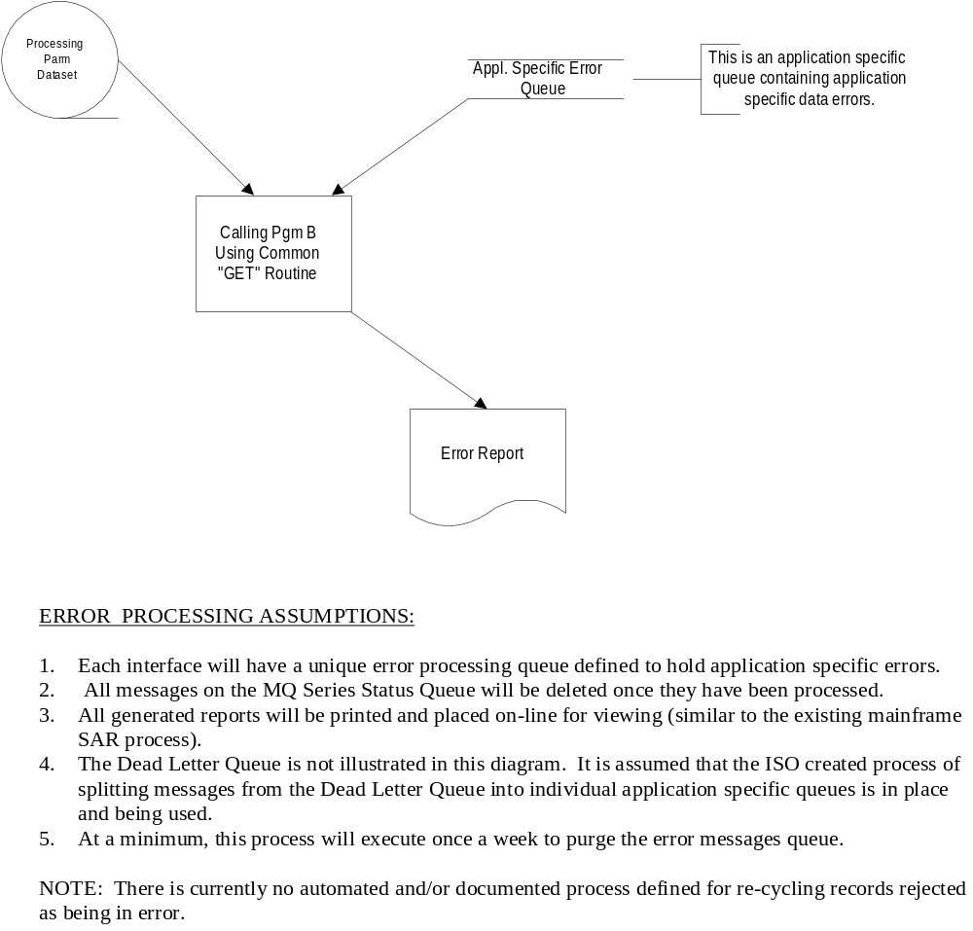

How to Use Common Error Processing Routines
To be completed in a future release of this document.

UNDELIVERED (Dead Letter) MESSAGE PROCESSING

Introduction
This section provides a high level overview as well as detailed information on how to use the centrally developed undelivered message process defined for data exchanges between legacy applications and SAP.

High-Level Undelivered Message Schematic
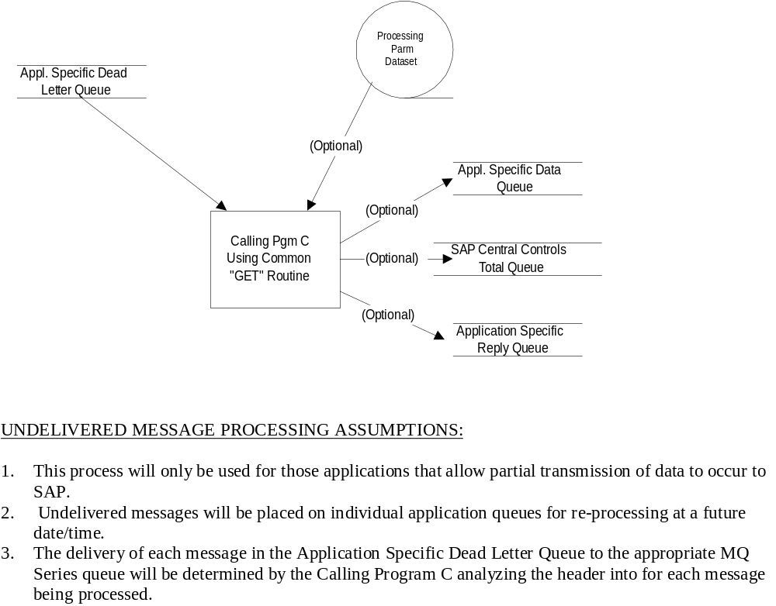

How to Use the Undelivered Message Process

Introduction

The KO MQ Series Dead Letter Queue Program is designed to exercise a common KO developed “wrapper” to the MQ Series API. The program gets data and control messages from an application interface specific Dead Letter Queue and puts them back on the application interface's data or control queue based on the message type.

General Design Assumptions

- This program does not contain business logic. It gets a message of the Dead Letter Queue, removes the Dead Letter Header, and puts the message back on the specified data or control queue.

- This program only recognizes message formats of "String", "Dead Letter", or messages that were originally "String" format.

- This program places data on only 2 queues, an application data queue, and a batch control queue. Messages of type "Datagram" are placed on the specified data queue. Messages of type "Request" are placed on the specified control queue.

- It is assumed only Datagram or Request type messages are present on the Application Specific Dead Letter Queue. If a message with any other type is present on the Application Specific Dead Letter Queue, it must be removed by some other means before this program can continue processing other messages on the Dead Letter Queue.

- This program will only run on the Win32 environment and on AIX. A comparable version is also available for MVS.

- This program does not address Database Connectivity or coordinating Message Queue Activity with Database Activity.

- Currently, it is assumed the user will always specify a Data Queue and a Control Queue. This program must open both queues successfully before processing the Dead Letter Queue.

- It is assumed implicit Commits and Rollbacks of the MQ Series are sufficient to handle abnormal program termination or Queue Manager Disconnects without explicit commits or rollbacks. Assuming additional code in our KO API is not necessary.

- This default behavior differs by platform and must be considered in future iterations and platform ports.

- On NT and AIX, if a program disconnects from a Queue Manager with work pending, without doing a commit or rollback, MQ Series performs an implicit Commit.

- On NT and AIX, if a program terminates without disconnecting from the Queue Manager while work is pending, MQ Series performs an implicit Rollback, assuming the program terminated abnormally.

Inputs and Outputs

The program reads an input parameter file to determine operating parameters, such as queue manager names, queue names, and log file names. The parameter filename is passed to the program as a command line option. The program gets messages of the Application Specific Dead Letter Queue and removes the Dead Letter Header. If the message type is "Datagram", the message is put on the Application Specific Data Queue. If the message type is "Request", the message is put on the specified Control Queue. Program activity is logged to the specified log file.

Each Dead Letter Queue message is treated as its own logical unit of work. The message is retrieved from the Dead Letter Queue and Put on the Data or Control Queue. If the Put is successful, the Get and Put are committed.

Inputs

This program reads a… | to…
Parameter File | get job and operational values, such as the Queue and Queue Manager Name to connect to, the maximum number of messages to place on a queue before doing a commit, etc.
Dead Letter Queue | get the messages that should be redirected to the specified Data or Control Queue.

Parameter File Format

The parameter file contains named parameters and their values. An equal sign, “=”, separates the parameter name from the value. Lines beginning with a semi-colon, “;” may contain comments and are ignored.

The parameter file contains the following parameters:

QMgrName | The name of the Queue Manager to connect to.  This must be an alphanumeric value of no more than 48 characters and is required.
DataQueueName | The name of the queue receiving application data.  This must be an alphanumeric value of no more than 48 characters and is required.
ControlQueueName | The name of the queue receiving batch control information.  This must be an alphanumeric value of no more than 48 characters and is required.
DeadLetterQueueName | The name of the Application Specific Dead Letter Queue, which contains previously sent Data or Control Messages that could not be delivered.  This must be an alphanumeric value of no more than 48 characters and is required.
BufferSize | Indicates how large a buffer should be allocated for receiving message data. This value should be larger than the largest message size expected.  This must be a numeric value between 2 and 4194305 and is required.
LogFileName | Represents the name of the output file used to log status and error information. If the file exists, it will be overwritten.  This must be an alphanumeric value, representing a legal filename and is required.

Outputs

- Interface Data Queue – Application Specific Dead Letter Queue Messages of type "Datagram" are Put on this Queue.

- Interface Control Queue – Application Specific Dead Letter Queue Messages of type "Request" is Put on this Queue.

- Program activity is logged to the specified log file.

Locating the Common “DLQ” Executables

To be documented in a future release of this document.

Examples of Using the Common “DLQ” Solution
In order to assist first time users of these modules, examples for each of the supported platforms have been included in the appendix. The individual examples are located as follows:

Appendix K – Sample “DLQ” Parameter File

MESSAGE CONFIRMATION PROCESSING

Introduction
This section provides an Introduction of the message confirmation process defined for data exchanges between legacy applications and SAP. As details of this process are better understood, additional information will be added to this section

Please note: This functionality is not currently available. Once a lower level of requirements was analyzed, it was determined that this functionality was not needed based on the current Legacy/SAP Interface Model.

High-Level Confirmation Message Schematic
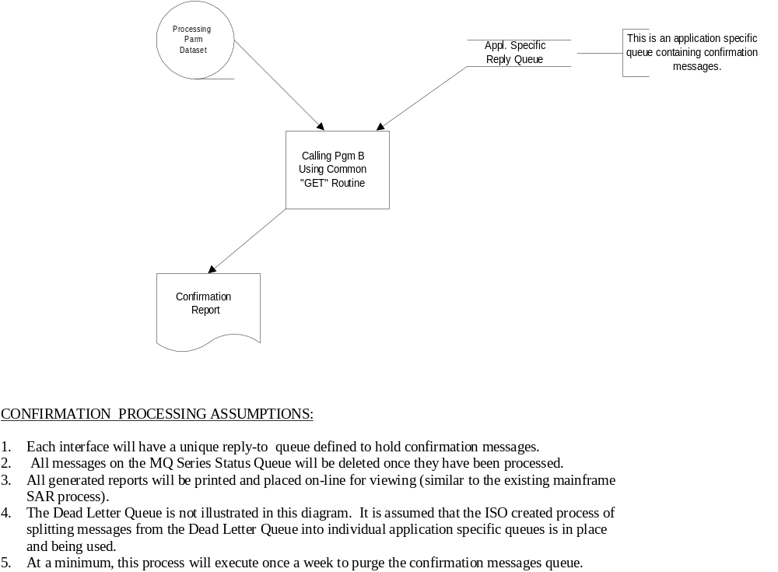

How to Use the Confirmation Message Process
To be completed in a future release of this document.

Appendices

Appendix A - MQ Series Roles & Responsibilities

A general MQ Series Roles & Responsibilities matrix can be found in the IS Infinity Align Doc Library in Lotus Notes. Specific roles in support of MQ Series during the SAP Interface work are as follows:

- ADSS is responsible for the ongoing maintenance, enhancement, and documentation of common MQ Series code. Sandy Beem and David Tamkun are the contact points.
- ISO is responsible for the establishment of queues. Blair Belton is the primary contact point.

Appendix B - Change Management Process & Procedures for Common Routines

Introduction
As common components are increasingly reused within the TCCS development environment, the management of versions of these components, as well as the manner in which they are “released” for use by developers, will become increasingly important. For example, if a “bug” is found in a component that is used by multiple applications, not all applications may exercise the code, which is broken. When a fix is made to that particular area, there is a possibility that something within the component might have been changed that will now “break” some of the other applications that had not been impacted previously.

This section includes general guiding principles and procedures for ensuring changes to shared components and programs are managed so as to mitigate the risks to all users of the components. For further descriptions of the roles and responsibilities referred to in this section, please see the Re-use documentation contained in the Developer’s Knowledge Base. [Mary’s comment – please let folks know where the Developer’s Knowledge Base is located]

For purposes of the common MQ Series programs, the following assumptions should be made:

- ADSS will function as a central maintenance body to the common MQ Series code.
- ADSS will set-up a Tracker implementation, to track and manage changes to the common MQ Series code.
- ADSS will function as Knowledge Coordinator, Component Content Owner, and Knowledge Coordinator for the common MQ Series code.

If there are any problems, or questions about the process, please contact Sandy Beem at x66240.\

Change Management Guiding Principles

Guiding principles have been defined for six (6) aspects of change management for shared components/programs. They are:

- Component Administration
- Limit modification and creation of new components – Modify or create whenever the change will legitimately improve the component for reuse in the future. But practice extending current component’s functionality by using it in conjunction with other reusable components wherever possible.
- Follow established processes for developing new components or enhancing current components.
- Ensure that components register which applications, or other components, use or refer to them, i.e., Where Used list.
- Provide on-going communication about component availability, use and reuse successes.

- Component Enhancement Requests
- Requests for enhancement to shared components will be documented and tracked.
- Enhancement requests will be analyzed prior to approval and prioritization – A formal impact analysis will be conducted prior to any work commencing. This impact analysis will include:
- Assessment of need for the enhancement(validity of the request).
- Analysis of where the component will be used and the potential “ripple effect” of any changes.
- Identification of interdependencies with other components or software (e.g., component changes that might require an upgrade to newer versions of commercial software/hardware, such as groupware, operating systems, databases, etc.)
- Documented approval of enhancement request to begin work on component.

- Component Version Availability
- Code fixes to component “bugs” will be made available immediately following their completion and testing.
- New components, or enhancements to components that have no interdependencies to other components or system hardware/software environment upgrades, will be made available to developers immediately following their completion and testing.

- Adoption of Changed Component
- Adoption or incorporation of a changed component will be optional – Incorporation of a changed component retroactively will be left to the discretion of the appropriate application developer, with some mandatory guidelines. For example, if a developer has previously chosen not to upgrade the component version in the application, multiple versions now exist, and the decision is made to sunset support for that early version in limited use, then those applications using the earlier version would be required to upgrade.
- Adoption of a change component will be influenced by interdependencies on other components or hardware/software, or purchased software environment changes.

- Documentation Strategy and Guidelines
- Documentation for all reusable components will be required, and will include (at a minimum):Description of component
- Certain technical information, such as required input parameters, parameters output, etc.
- Component test plan
- Component test data and results
- Documentation help file

- Version Tracking Strategy
- Follow Company standard for change and version tracking.

Change Management Procedures

Change Request Initiation

Purpose
Records all information required to define a change.

Prerequisites
- Need for a change has been identified.

Procedures

Step | Responsibility | Action | Reason
1.1 | Change Requester  (Developer) | Send e-mail requesting a change to the ADSS Change Coordinator (Sandy Beem). Included in the request should be:  - A description of the change in functionality  - Business rationale for the change  - Requested timing of the change  - Criticality of the change  - Platform needing the change  - Contact name and number | Everyone does not have access to the Tracker software. E-mail is being substituted to collect the information, which will be centrally entered into Tracker.
1.2 | ADSS Change Coordinator | Obtain a change control number for the change request. Enter the request into Tracker. | Defines the change; will be referenced by content owner, impacted parties, and approvers of change

Preliminary Impact Analysis

Purpose
Determine application(s), related components, and Content Owners that are potentially impacted by the requested change.

Prerequisites
- Change request has been completed.
- Availability of up-to-date “Where Used” list

Procedures

Step | Responsibility | Action | Reason
2.1 | Knowledge Coordinator | Review “Where Used” list for all components to be changed | Identifies all applications and other components that use, or depend on, the component to be changed.
2.2 | Knowledge Coordinator | Review change request for completeness. | Determine if additional information is needed to analyze the request.
2.3 | Knowledge Coordinator | Determine Application System Owner for all impacted systems | Notifies application system owners that a change has been proposed that may impact their production system.
2.4 | Knowledge Coordinator | Determine Component Content Owner for all impacted components. | Identifies each impacted component content owner who will be responsible for implementing the change.
2.5 | Knowledge Coordinator | Notify all impacted parties (Application System Owner and Component Content Owner) about the requested change | Allows impacted parties to review the proposed change.
2.6 | Knowledge Coordinator | Review other proposed changes to make a preliminary determination whether there are changes to other components, which impact similar application systems, or related components. | Identifies the “ripple effect” of changes that could be made at the same time (“bundled”) to minimize testing, systems impact, etc.
2.7 | Knowledge Coordinator | Complete preliminary impact analysis. | Identifies preliminary estimate of magnitude of proposed change.

Detailed Impact Analysis

Purpose
Identifies all components within each system that will be impacted by the requested change. Identifies the tasks that will be required to implement the requested change within each system. Estimates the cost, resources, and time that will be required to implement the requested change.

Prerequisites
- Preliminary impact analysis, identifying the application system owners and component content owners impacted by the change.
- Knowledge Coordinator and Component Content Owner have access to Change Request information.

Procedures

Step | Responsibility | Action | Reason
3.1 | Component Content Owner | Review appropriate change request forms, “Where Used” list, and preliminary impact analysis | Assesses type of change and what additional detailed impact analyses should be performed.
3.2 | Component Content Owner | Identify tasks required to make the change to a component | Provides further detailed information as input to detailed impact analysis.
3.3 | Component Content Owner | Confirm related components / systems that will be impacted by change | Determine other types of components that the changed component may impact. Will have direct bearing on approach to both completing a change to a component and releasing it to developers.
3.4 | Component Content Owner | Develop estimate of resources, elapsed time and cost of implementing the change. | Provides detailed input to detailed impact analysis
3.5 | Component Content Owner | Determine feasibility of making the change. Provide a preliminary recommendation to complete (or to reject) making the change. | Determines if and when a change should be implemented.

Consolidation/Notification

Purpose
Summarizes detailed impact assessments and solicits approval/prioritization for change from Reuse Content Committee.

Prerequisites
- Detailed Impact Analysis
- Current workload of Content Owners

Procedures

Step | Responsibility | Action | Reason
4.1 | Knowledge Coordinator | Review detailed impact analyses. | Determine thoroughness of reports and assess input from content owners.
4.2 | Knowledge Coordinator | Follow up with any content owners who have not responded with issues. | Insure all issues are identified and communicated, including interactions with other components.
4.3 | Knowledge Coordinator | Summarize cost/benefits and preliminary recommendation. | Complete concise format for Reuse Content Committee review.
4.4 | Knowledge Coordinator | Route change request, summary and detailed impact analyses, and preliminary recommendations to Reuse Content Committee and Component Content Owners for approval. | Makes all information available to Reuse Content Committee and Component Content Owners.

Approval

Purpose
Provides approval, denial, postponement, or re-scoping of the change request.

Prerequisites
- Change Requests
- Detailed Impact Analyses
- Change Recommendations

Procedures

Step | Responsibility | Action | Reason
5.1 | Reuse Content Committee | Evaluate requested change and impact assessments. | Evaluates pros and cons of implementing the change.
5.2 | Reuse Content Committee | Determine whether change request should be approved for completion, denied, or postponed . Record decision and, reason for it, on the change request. | Provides final approval or denial for implementation of the requested change.
5.3 | Reuse Content Committee | Prioritize changes. | Establishes timing requirements for making change, and identifies related components that should be changed and tested, implemented together (“bundled” as part of the release process).
5.4 | Development Managers | Identify when change can be made, based on available resources. | Schedules developer workload, based on priorities of all requested work.
5.5 | Knowledge Coordinator | Notify affected parties of change request status (approval / denial / postponement; prioritization / projected timing of completion of change). | Communicates status of change request to the Change Requester and associated parties.

Appendix C - MQ Series Common Routine Errors

The codes provided in this section are defined specifically as special return codes from the common MQ Series programs written at The Coca-Cola Company. For all other MQ Series Reason Codes that could be returned, please refer to the MQ Series documentation.

Reason Codes sorted by Code.

CODE | VALUE
KORC_UNSPECIFIED | 65536L
KORC_INVALID_OPEN_OPT | 65537L
KORC_INVALID_Q_NAME | 65538L
KORC_INVALID_BUFFER | 65539L
KORC_BUFFER_TOO_BIG | 65540L
KORC_INVALID_MSG_ID | 65541L
KORC_INVALID_CORREL_ID | 65542L
KORC_INVALID_REPLY_Q_NAME | 65543L
KORC_INVALID_MSG_SIZE | 65544L
KORC_INVALID_EXPIRE | 65545L
KORC_UNUSABLE_QMGR_CONN | 65546L
KORC_NEW_CQUEUE_FAIL | 65547L
KORC_MAX_QUEUES_EXCEEDED | 65548L
KORC_INVALID_QID | 65549L
KORC_INVALID_QID_NOT_OPEN | 65550L
KORC_INVALID_QMGR_NAME | 65551L
KORC_QMGR_NOT_CONNECTED | 65552L
KORC_INVALID_STRING_BUFF | 65553L
KORC_INVALID_STRING_BUFF_SIZE | 65554L
KORC_QMGR_ALREADY_CONNECTED | 65555L
KORC_INVALID_GET_MODE | 65556L
KORC_INVALID_WAIT_INTERVAL | 65557L
KORC_BUFFER_TOO_SMALL | 65558L
KORC_INVALID_MSG_ID_LEN | 65559L
KORC_INVALID_CORREL_ID_LEN | 65560L
KORC_INVALID_REPLYTOQ_LEN | 65561L
KORC_INVALID_FORMAT_LEN | 65562L
KORC_OPEN_INPUT_FAIL | 66000L
KORC_NOT_IMPLEMENTED | 66001L
KORC_LINE_WIDTH_EXCEEDS_BUFFER | 66002L
KORC_INVALID_BUFFER_SIZE | 66003L
KORC_MEMORY_ALLOC_FAIL | 66004L
KORC_PARM_COLL_GETVALUE_FAILED | 66005L
KORC_UNEXPECTED_MSG_TYPE | 66006L
KORC_ROLLBACK_DUE_TO_PREV_ERR | 66007L
KORC_OPEN_OUTPUT_FAIL | 66008L
KORC_WRITE_TO_OUTPUT_FAIL | 66009L
KORC_MISSING_COMMAND_PARMS | 66010L
KORC_NONNUMERIC_CMD_PARM | 66011L
KORC_INTERNAL_ERR_CMD_PARM_GAP | 66012L
KORC_NONNUMERIC_PARM | 66013L
KORC_INTERNAL_ERR_CMD_FLAG_BAD | 66014L
KORC_MISSING_PARMS | 66015L
KORC_INTERNAL_ERR_MAX_PARMS | 66016L
KORC_INTERNAL_ERR_PARM_NOT_FND | 66017L
KORC_INTERNAL_ERR_POSIT_PRM_NF | 66018L
KORC_PARM_FLAG_NOT_FOUND | 66019L
KORC_INTERNAL_ERR_BAD_FLAG | 66020L
KORC_INTERNAL_ERR_MQAPI_NOTREG | 66021L
KORC_PARM_SYNTAX_ERROR | 66022L
KORC_INPUT_READ_FAIL_NOT_OPEN | 66023L
KORC_INVALID_PARM_FILE_WIDTH | 66024L

Appendix D – ISO Central Dead Letter Queue Process

One central Dead Letter queue is defined on each platform running MQ Series. An ISO process analyzes all messages contained within each central Dead Letter queue, on a regularly scheduled basis. This process retrieves each message from the queue and places it on the appropriate application specific dead letter queue, as determined by the information contained within the dead letter queue header.

Once the central dead letter queue messages have been successfully processed, they are removed from the central queue.

Appendix E – Request for MQ Series Development/Test Queues

REQUEST FOR MQSERIES QUEUES

1. REQUESTER:___________________DEPT:_________ DATE:__/__/____

2. PROJECT :___________________SPONSOR:_____________________

3. SOURCE SERVER NAME: 4. TARGET SERVER NAME:

_______________________________ ___________________________

5. QUEUE NAME DEFINITIONS:

QUEUE NAME Msg size Max # of msgs Persistent (yes or no)
(Should begin with USTCCCAA.
and be no more than 40 characters)

Group ___________________ Browse Mqinq Put Get

Group ___________________ Browse Mqinq Put Get

Group ___________________ Browse Mqinq Put Get

For each Queue Name specify which groups should have access to the Queue
An Error Queue is recommended for each Queue, suffix of -.ERR
A Reply Queue is recommended, suffix of -.REP
A Dead Letter Queue is recommended, suffix of -.DLQ

6. TRIGGER DEFINITIONS: (optional)
QUEUE NAME PROGRAM NAME TO EXECUTE ON TRIGGER TYPE OF TRIGGER
FIRST EVERY DEPTH

7. CHANGES TO EXISTING QUEUES:

QUEUE NAME TYPE OF CHANGE

Appendix F – “PUT” Solution: MQ Series Windows 95 Client Interface Example

1. Is the interface a good candidate for a Windows 95 Client Interface?

Open Issue: Guidelines to be determined.

2. Verify workstation requirements.
The MQ Series client workstation should have:
- roughly 4 MB of disk space available for the MQ Series Client software
- 32 MB or more of RAM
- At least a Pentium 100 Mhz processor

3. Request MQ Series for Windows 95 Client Software.
Email a request to Dawit Bizuwork, of UBAS, and send a copy to Blair Belton requesting the software. Dawit will log the request and deliver the software via WinInstall or other means. By default, the MQ Client software is installed in the c:\mqclient folder.

ADSS Utilities for putting data on the queue, checking for errors, and resending undelivered messages are also installed by the MQ Client delivery process and are installed in the c:\mqclient\bin folder.

4. Decide on a location for your interface files.
The Rolling Estimates application stores its upload files in APPLSERV/SYS:\ISFINANC\COSTTRAC\UPLOADGL\yymm, where yymm changes each month to reflect the year and month of the data involved. The team plans to use a batch file to change to the appropriate directory each month.

For the remainder of this document, assume the team files are stored in N:\ISFINANC\COSTTRAC\UPLOADGL.

5. Collect the information needed to create the parameter file for the KOMQPUT utility.
You need to identify the following information. As an example, the values for the Rolling Estimates System are provided.

- The Queue Manager Name to connect to. example: USALG000

- The name of your application specific Data Queue. example: USTCCCAA.CORPIS.ROLLEST

- The name of the Control Queue. This is the same for all SAP Inbound interfaces and should be "USTCCCAA.ZINFIN.BATCNTL".

- The name of your application specific Reply Queue. This is required for optional confirmation processing and for the return of undeliverable messages. The ISO Dead Letter queue process uses this queue name to determine the name of your application's Dead Letter Queue. example: TBD

- The name of your application specific Error Queue. KOMQPUT puts a message on this queue to indicate whether or not it successfully placed your data on the queue. The message either contains a description of the error encountered, or "No Errors" to indicate no errors were encountered during the Put process. example: TBD

- The maximum number of messages that may be put on a queue before a "Commit" is performed must be specified. Most queues at TCCC are defined so that no more than uncommitted 4,000 messages can be placed on a queue. Depending on the size of your applications messages, you may need to commit more frequently. A value of 0 indicates that KOMQPUT should not commit until all your data is on the queue. If the queue's "maximum uncommitted" threshold is reached before all data is placed on the queue, a fatal error occurs and all messages are rolled back. example: 4000

- How long may messages remain on the queue unprocessed before they should be considered "out of date" and expire. This value represents milliseconds, so a value of 15000 indicates messages may remain on the queue for up to 15 seconds. A value of -1 indicates the messages should never expire. example: -1

- Your application's Partner Profile ID. This is used to populate the MQ Series Message ID field in the MQ Series Message Header. This does not affect the contents of your message data. example: BUDGET

- The location and name of a log file to record errors that may occur before queue connections are established. This can be a simple filename, or a fully qualified path and filename. example: N:\ISFINANC\COSTTRAC\UPLOADGL\uploadgl.log

- The location and name of your interface data file. This can be a simple filename, or a fully qualified path and filename. example: N:\ISFINANC\COSTTRAC\UPLOADGL\uploadgl.prn

- The location and name or your interface control file. This file can be a simple filename, or a fully qualified path and filename. example: N:\ISFINANC\COSTTRAC\UPLOADGL\uploadgl.ctl

- The maximum record width (line width) in your data file. If your control file is wider than your data file, specify the maximum width of your control file. This value may be bigger than your file width, but it must be at least equal to your maximum file width plus 1. example: 1024

- Create a parameter file for your interface

You can use Notepad or a similar editor to create this file. Note that lines beginning with semi-colons are ignored. Remember that you can specify fully qualified path and filenames for the log, data, and control files.

A sample parameter file for Rolling Estimates is pictured below:

;
; MQ Series SAP Inbound Interface Program Parameter File
; for IS Rolling Estimates
QMgrName=USALG000
DataQueueName=USTCCCAA.CORPIS.ROLLEST
ControlQueueName=USTCCCAA.ZINFIN.BATCNTL
ReplyToQName= USTCCCAA.to be determined.REP
ErrorQueueName=USTCCAA.to be determined.ERR
;
; Batch Interval represents the maximum number of Puts that can be placed on a queue
; before the program should issue a COMMIT. Ideally, Puts should not be committed
; until the entire batch has been placed on the queue. However, if the data feed
; is large enough, this may not be practical. The precise value will depend on the
; size of each message and how the application's queue is configured.
;
BatchInterval=4000
;
; Expiration Interval should be a number from 1 to ?? that represents how
; many tenths of a second a message can remain on a queue before it
; should be flushed from the system. The value -1 can be used to indicate
; that messages should never expire.
;
ExpirationInterval=-1
;
; The Message ID field is used to indicate the Interface the message data is a part of as
; well as a date timestamp representing the time period of the data. This is used to
; uniquely identify an entire batch of data. This value is placed in the MsgID field
; of every message.
;
MsgID=BUDGET
;
LogFileName=N:\ISFINANC\COSTTRAC\UPLOADGL\uploadgl.log
DataFileName=N:\ISFINANC\COSTTRAC\UPLOADGL\uploadgl.prn
ControlFileName=N:\ISFINANC\COSTTRAC\UPLOADGL\uploadgl.ctl
;
; The Buffer Size must be large enough receive the longest record in your data file
; plus one byte for a terminating NULL character. The maximum buffer size
; supported is 4194305, which is 4MB plus 1 byte.
;
BufferSize=1024

7. Execute the Put Utility
Go to a command prompt under Windows 95 and type "KOMQPUT parmfilename", where parmfilename is the filename of your parameter file for this interface. This can be a simple filename or a fully qualified path and filename.

Example: KOMQPUT N:\ISFINANC\COSTTRAC\UPLOADGL\ISREParmfile.txt

8. Determining the success or failure of the Put process
There are two ways to verify Put success or failure.

1. Examine the specified log file.

The parameters selected for the process and the outcome are captured in the log file. If an error occurs before the error queue can be opened successfully, this is the only way to determine the nature of the error. A successful example is pictured below.

KOMQPUT Version 1.0.02
Legacy to SAP MQ Series Put Utility
Thu Dec 10 15:13:42 1998

ParameterFile='N:\ISFINANC\COSTTRAC\UPLOADGL\isreparmfile.txt'
BatchInterval='0'
BufferSize='1024'
ExpirationInterval='1000'
ControlQueueName='USTCCCAA.ZINFIN.BATCNTL'
ControlFileName='uploadgl.ctl'
DataQueueName='USTCCCAA.CORPIS.ROLLEST'
DataFileName='N:\ISFINANC\COSTTRAC\UPLOADGL\uploadgl.prn'
LogFileName='N:\ISFINANC\COSTTRAC\UPLOADGL\uploadgl.log'
MsgID='BUDGET19981210151342'
QMgrName='USALG000'
ReplyToQName='USTCCCAA.to be determined.REP'
ErrorQueueName='USTCCAA.to be determined.ERR'

-- Control Message Put Successfully.
-- Final Commit Successful. 1769 messages put to data queue.
-- KOMQPUT exiting with code 0.

2. Run the error reporting utility to dump the application's Error Queue to a log file.

Appendix G – “PUT” Solution: MQ Series NT Interface Example

To be included in a future release of this document.

Appendix H – “PUT” Solution: MQ Series AIX Interface Example
To be included in a future release of this document.

Appendix I – “PUT” Solution: MQ Series Mainframe Interface Example

Technical Background
There are two different ways to use the mainframe MQ Series “PUT” routines. They are:

(1) Encapsulates the vendor provided interface and frees the caller from any linkage editor or binder requirements. There are no special JCL requirements are required for this scenario. For future reference, this option is called the batch option

(2) Encapsulates installation specific usage recommendations. For future reference, this option is called the programmatic option.

Calling Conventions
In order to use the programmatic option described above, parameters must be specified in two copybooks. The two copybooks are:

- Control Block
- Structured Buffer

Descriptions of these two copybooks follow.

1. Control Block
- Operation Codes are predefined in 88 levels to enable use of SET
- Buffer-length is required for the GET
- Record-length is required for the PUT and is set by the API on the GET
- Return code mapped to Completion Code in Doc
- Feedback area mapped to Reason Code in the Doc

2. Structured I/O Buffer
- Formatted fields comprise a Header
- The Length of the Buffer is not really significant

Installation Prerequisites
- Queues must be defined before you can reference them.
- You must have acf2 authorization for the queue you use.

Quick Reference

Copy Library: | Z8364A.MQPROD.COPY
- Mq0001 | Control Block Structure
- Mq0003 | I/O Buffer Structure

Sample Library: | Z8364A.MQPROD.SOURCE
- MQ0107 | Sample API Client

Load Library: | Z8364A.mqprod.loadlib
- MQ0107 | Sample Client Executable
- MQ0200 | MQ Series Application Programming Interface
- MQ0300 | MQ Series Component Interface

To Do List
- Queue Names | You need to obtain the name of a Message Queue, which has been defined to the operating system. Ref: Jim Davis
- ACF Auth | You need to be granted ACF2 access to any Queues you will be utilizing. Ref: Jim Davis
- Modify Sample when Using the Programmatic Option | You will need to insert a valid Queue Name into the Sample program
- Compile the Sample When Using the Programmatic | You will need to recompile the sample to include your Queue Name. In order to do this you must reference the Copy library indicated above.
- Verify with the Sample When Using the Programmatic Option | Run a test using the re-compiled sample. This will verify that you have the system level infrastructure in place for development of your own use of the message queue.  Note: MQ Series has no specific JCL requirements.

Annotated Sample

- There are no particular requirements in the ID or DATA divisions of a Cobol Program to use the MQ API.

IDENTIFICATION DIVISION.
PROGRAM-ID. MQ0107
AUTHOR. DANIEL R CREAGER
INSTALLATION. THE COCA-COLA COMPANY.
DATE-WRITTEN. DECEMBER 1998
DATE-COMPILED.

*----------------------------------------------------------------*
* DESCRIPTION: THIS IS A SAMPLE PROGRAM, WHICH ILLUSTRATES
* THE DETAILS OF USING THE COCA-COLA COMPANY'S
* MQ SERIES APPLICATION PROGRAMMING INTERFACE.
*----------------------------------------------------------------*
* HISTORY:
* 12/10/98 DRC SAMPLE CREATED.
*----------------------------------------------------------------*

ENVIRONMENT DIVISION.
DATA DIVISION.

- This sample uses variables for the program names to assure that dynamic calls are made to the load library. This avoids the need for specific linkage editor or binder requirements. Note that the Queue Manager used in the sample is only valid on System D. It will be necessary to replace [MY.QUEUE] with a valid message queue name to which you have been granted ACF2 access.
WORKING-STORAGE SECTION.
01 WS-CONSTANTS.
05 WS-QUEUE-MANAGER PIC X(08) VALUE 'MQ0200'.
05 WS-QUEUE-MGR-NAME PIC X(08) VALUE 'MQD0'.
05 WS-MSG-QUEUE-NAME PIC X(48) VALUE 'MY.QUEUE'.
05 WS-SAMPLE-MSG PIC X(12) VALUE 'âSAMPLE MSGã'.

- Because the MQ API utilized two storage areas a copy books have been prepared defining both of these structures. The first is refereed to as the Control-Block and the second is a structured IO-Buffer. It is refereed to as a structured buffer because there are specific field definitions, which constitute a header to the free-format area you will use to pass data to the message queue. The replace clause is utilized to enable the possibility of having multiple of these structures within a single client program.

01 WS-MSG-QUEUE-CB.
COPY MQ0001 REPLACING ==:TAG:== BY ==MQCB==.

01 WS-IO-BUFFER.
COPY MQ0003 REPLACING ==:TAG:== BY ==WIB==.

- When using the copy book it is strongly suggested that you initialize both of the requisite API structures.
The first call in the required calling sequence must always be an INIT, which requires that you provide the name of the Queue Manager you will be using. This call establishes a connection to the shared system queue manager.
After every call the Return code and Feedback area of the Control block will contain the two values refereed to in MQ Series documentation as the Completion Code and the Reason Code respectively.
PROCEDURE DIVISION.
A010-MAIN.
*---------------------------------------------------------------*
* CONNECT TO THE QUEUE MANAGER
*---------------------------------------------------------------*
INITIALIZE WS-MSG-QUEUE-CB
WS-IO-BUFFER
SET MQCB-INIT TO TRUE
MOVE WS-QUEUE-MGR-NAME TO WIB-QUEUE-MGR-NAME
PERFORM X010-MSG-QUEUE-INTERFACE
IF NOT MQCB-SUCCESSFUL-REQUEST
DISPLAY 'ERROR OPENING QUEUE MANAGER'
DISPLAY MQCB-RETURN-CODE ':' MQCB-FEEDBACK-AREA
END-IF

- The second call in the required calling sequence must always be an INIT-QUEUE, which requires that you provide the name of the Queue you will be using. This call establishes a connection to the specific queue with which you will be interacting.
Note: Your client code must set the OUTPUT indicator before you make the INIT-QUEUE call.
*---------------------------------------------------------------*
* OPEN AN INDIVIDUAL QUEUE
*---------------------------------------------------------------*
SET MQCB-INIT-QUEUE TO TRUE
SET MQCB-OUTPUT TO TRUE
MOVE WS-MSG-QUEUE-NAME TO WIB-QUEUE-NAME
PERFORM X010-MSG-QUEUE-INTERFACE
IF NOT MQCB-SUCCESSFUL-REQUEST
DISPLAY 'ERROR OPENING MESSAGE QUEUE'
DISPLAY MQCB-RETURN-CODE ':' MQCB-FEEDBACK-AREA
END-IF

- The third call in the required calling sequence will usually be one or a series of PUT calls. PUT requires that you’ve set the Correlation-Id and the Record-Length fields with valid values. The Buffer-Length field should be set for compatibility with eventual GET calls in the future.
*---------------------------------------------------------------*
* PUT A DATA MESSAGE ON THE QUEUE
*---------------------------------------------------------------*
SET MQCB-PUT TO TRUE
MOVE WS-SAMPLE-MSG TO WIB-BUFFER
MOVE LENGTH WIB-BUFFER TO MQCB-BUFFER-LENGTH
MOVE LENGTH WS-SAMPLE-MSG TO MQCB-RECORD-LENGTH
MOVE 1 TO WIB-CORR-ID
PERFORM X010-MSG-QUEUE-INTERFACE

IF NOT MQCB-SUCCESSFUL-REQUEST
DISPLAY 'ERROR PUTTING MESSAGE ON THE QUEUE'
DISPLAY MQCB-RETURN-CODE ':' MQCB-FEEDBACK-AREA
END-IF

- The commit call is NOT NECESSARY ON EVERY CALL as illustrated in the sample client. It will be necessary to use the Commit whenever your client processes more than 4,000 messages as a batch. Failure to commit multiple messages at least every 4,000 can result in errors.

*---------------------------------------------------------------*
* COMMIT THE MESSAGE TO THE QUEUE
*---------------------------------------------------------------*
SET MQCB-COMMIT TO TRUE
PERFORM X010-MSG-QUEUE-INTERFACE

IF NOT MQCB-SUCCESSFUL-REQUEST
DISPLAY 'ERROR COMMITTING THE MESSAGE'
DISPLAY MQCB-RETURN-CODE ':' MQCB-FEEDBACK-AREA
END-IF

- After putting all the desired records into a message queue it is highly advisable to correctly close the message queue and then disconnect from the queue manager.

*---------------------------------------------------------------*
* CLOSE THE QUEUE
*---------------------------------------------------------------*
SET MQCB-CLOSE TO TRUE
PERFORM X010-MSG-QUEUE-INTERFACE

IF NOT MQCB-SUCCESSFUL-REQUEST
DISPLAY 'ERROR CLOSING THE QUEUE'
DISPLAY MQCB-RETURN-CODE ':' MQCB-FEEDBACK-AREA
END-IF

*---------------------------------------------------------------*
* DISCONNECT FROM THE QUEUE MANAGER
*---------------------------------------------------------------*
SET MQCB-DISCONNECT TO TRUE
PERFORM X010-MSG-QUEUE-INTERFACE

IF NOT MQCB-SUCCESSFUL-REQUEST
DISPLAY 'ERROR DISCONNECTING THE QUEUE MANAGER'
DISPLAY MQCB-RETURN-CODE ':' MQCB-FEEDBACK-AREA
END-IF

GOBACK.

- The interface paragraph has been isolated in the sample simply to avoid overly verbose coding. There is no technical reason why this code could not have been in-line with the rest. Moving the return code to the Cobol system return code field has also been included here only for clarity rather than duplicating this same code after each call in-line.

*---------------------------------------------------------------*
* QUEUE MANAGER INTERFACE
*---------------------------------------------------------------*
X010-MSG-QUEUE-INTERFACE.
CALL WS-QUEUE-MANAGER USING WS-MSG-QUEUE-CB
WS-IO-BUFFER
MOVE MQCB-RETURN-CODE TO RETURN-CODE.

Dataset Listing

Development Datasets:
Z8364A.MQDEVL.COPY
Z8364A.MQDEVL.JCL01
Z8364A.MQDEVL.LIST
Z8364A.MQDEVL.LOADLIB
Z8364A.MQDEVL.PROCLIB
Z8364A.MQDEVL.SOURCE
Z8364A.MQDEVL.SOURCE.BKUP1204
Z8364A.MQDEVL.SOURCE.BKUP1210
Z8364A.MQDEVL.SOURCE.BKUP1211

Development Testing Datasets:
Z8364A.MQDEVL.CNTL
Z8364A.MQDEVL.INPUT01
Z8364A.MQDEVL.INPUT02
Z8364A.MQDEVL.JCL02
Z8364A.MQDEVL.PROCLIB

Acceptance Testing Datasets:

File Interface Datasets
Z8364A.MQTEST.CNTL
Z8364A.MQTEST.JCL
Z8364A.MQTEST.LIST
Z8364A.MQTEST.LOADLIB
Z8364A.MQTEST.PROCLIB

Programming Interface Datasets
Z8364A.MQTEST.COPY
Z8364A.MQTEST.SOURCE

Production Datasets:

File Interface Datasets
Z8364A.MQPROD.CNTL
Z8364A.MQPROD.JCL
Z8364A.MQPROD.LIST
Z8364A.MQPROD.LOADLIB
Z8364A.MQPROD.PROCLIB

Programming Interface Datasets
Z8364A.MQPROD.COPY
Z8364A.MQPROD.SOURCE

Job Control Language (JCL)

JCL Decks:
// JCLLIB ORDER=(Z8364A.MQTEST.PROCLIB)
//*--------------------------------------------------------------------
//* EXECUTE THE MQ SERIES PUT QUEUE UTILITY
//*--------------------------------------------------------------------
//*
//JS1 EXEC MQ0100,APPL=TESTRUN1
//PS1.SYSPARM DD DISP=SHR,DSN=Z8364A.MQTEST.CNTL(INVOICE)
//PS1.SYSUT1 DD DISP=SHR,DSN=A01452.ISI.BATCH
//PS1.SYSUT3 DD DISP=SHR,DSN=A01452.ISI.MESSAGE
//
//

// JCLLIB ORDER=(Z8364A.MQTEST.PROCLIB)
//*--------------------------------------------------------------------
//* PRINT OUT THE QUEUES WITH THE NEW CONTENTS
//*--------------------------------------------------------------------
//JS1 EXEC MQPRINT,QUEUE=/USTCCCAA.CREAGER.QUEUE

// JCLLIB ORDER=(Z8364A.MQTEST.PROCLIB)
//*--------------------------------------------------------------------
//* CLEAR OUT THE QUEUES FOR TESTING
//*--------------------------------------------------------------------
//JS1 EXEC MQPURGE,QUEUE=/USTCCCAA.CREAGER.QUEUE

JCL Procedures:

//MQ0100 PROC PARMLIB=Z8364A.MQTEST.CNTL,
// CNTLPARM=MQ0004,
// OPR='P',
// DEBUG='P',
// APPL='MQ0100',
// SYSOUT=*
//*--------------------------------------------------------------------
//*
//* MQ SERIES BATCH UTILITY
//*
//*--------------------------------------------------------------------
//PS1 EXEC PGM=MQ0100,REGION=4M,PARM='&OPR&DEBUG&APPL'
//STEPLIB DD DISP=SHR,DSN=Z8364A.MQTEST.LOADLIB
//SYSUDUMP DD SYSOUT=&SYSOUT
//SYSOUT DD SYSOUT=&SYSOUT
//SYSPARM DD DISP=SHR,DSN=&PARMLIB(&CNTLPARM) PARM IN
//SYSLOG DD SYSOUT=&SYSOUT LOG
//SYSUT1 DD DUMMY DATA IN
//SYSUT2 DD DUMMY CNTL IN

//MQPRINT PROC QUEUE='/USTCCCAA.CREAGER.QUEUE',
// LOADLIB=Z9080X.PUBLIC.LOAD,
// SYSOUT=*
//*--------------------------------------------------------------------
//*
//* PRINT MESSAGES IN A QUEUE VIA BROWSE
//*
//*--------------------------------------------------------------------
//JS1 EXEC PGM=MQS006,REGION=4M,PARM='&QUEUE'
//STEPLIB DD DISP=SHR,DSN=&LOADLIB
//SYSPRINT DD SYSOUT=&SYSOUT
//PLIDUMP DD SYSOUT=&SYSOUT
//SYSUDUMP DD SYSOUT=&SYSOUT

//MQPURGE PROC QUEUE='/USTCCCAA.CREAGER.QUEUE',
// LOADLIB=Z9080X.PUBLIC.LOAD,
// SYSOUT=*
//*--------------------------------------------------------------------
//*
//* EMPTY QUEUE
//*
//*--------------------------------------------------------------------
//PS1 EXEC PGM=MQS004,REGION=4M,PARM='&QUEUE'
//STEPLIB DD DISP=SHR,DSN=&LOADLIB
//SYSPRINT DD SYSOUT=&SYSOUT
//PLIDUMP DD SYSOUT=&SYSOUT
//SYSUDUMP DD SYSOUT=&SYSOUT

Job Control Parameters
**----------------------------------------------------------------**
** THESE PARAMETERS CONTROL THE MQ SERIES UTILITY ON MVS
**----------------------------------------------------------------**
QUEUE-MGR-NAME=MQD0 *REQUIRED
CONTROL-QUEUE-NAME=USTCCCAA.CREAGER.BATCNTL *REQUIRED
DATA-QUEUE-NAME=USTCCCAA.CREAGER.QUEUE *REQUIRED
REPLYTO-QUEUE-NAME=USTCCCAA.CREAGER.REP
ERROR-QUEUE-NAME=USTCCCAA.CREAGER.ERR
DEADLTR-QUEUE-NAME=USTCCCAA.CREAGER.DLQ
BUFFER-SIZE=500
BATCH-INTERVAL=1000
EXPIRATION-INTERVAL=-1
MESSAGE-ID=MSGFMT-009
INPUT-EXIT=MQ0101
OUTPUT-EXIT=MQ0102
DATA-FILE-NAME=SYSUT1
CONTROL-FILE-NAME=SYSUT2

Sample Output
10001 APPLICATION: TESTRUN1 VERSION 1.0.02
10001 DESCRIPTION: LEGACY TO SAP MQ SERIES PUT UTILITY
10302 PARAMETER SETTINGS:
10302 BUFFER SIZE: 32,760
10302 BATCH INTERVAL: 100
10302 EXPIRATION INTERVAL: 1-
10302 MESSAGE ID: MSGID
10302 INPUT EXIT: MQ0101
10302 OUTPUT EXIT: MQ0102
10302 QUEUE MGR NAME: MQD0
10302 MESSAGE QUEUE NAME: USTCCCAA.AMSAAP0.INVOIC.ISI
10302 CONTROL QUEUE NAME: USTCCCAA.ZINFIN.BATCNTL
10302 REPLY-TO QUEUE NAME: USTCCCAA.AMSAAP0.INVOIC.ISI.REP
10302 ERROR QUEUE NAME: USTCCCAA.AMSAAP0.INVOIC.ISI.ERR
10302 DEAD LETTER QUEUE NAME: USTCCCAA.AMSAAP0.INVOIC.ISI.DLQ
10302 DATA FILE NAME: SYSUT1
10302 CONTROL FILE NAME: SYSUT3
10601 DATA MESSAGES WRITTEN 141
10602 SYNC POINTS ISSUED: 1
10601 CONTROL MESSAGES WRITTEN 1
10602 SYNC POINTS ISSUED: 0

Appendix J – Sample “GET” Parameter File

QMgrName=USALG000
DataQueueName=USTCCCAA.INTERFACE.DEV
ControlQueueName=USTCCCAA.INTERFACE.DEV2
;ReplyToQName=USTCCCAA.INTERFACE.DEV3
BatchInterval=10
BufferSize=236
LogFileName=log.txt
DataFileName=gotten_data.txt
ControlFileName=gotten_control.txt
;ErrorQueueName=USTCCCAA.INTERFACE.DEV4
RestartFileName=komqget.rst

Appendix K – Sample DLQ Parameter File

QMgrName=USALG000
DeadLetterQueueName=USTCCCAA.INTERFACE.DLQ
DataQueueName=USTCCCAA.INTERFACE.DEV
ControlQueueName=USTCCCAA.INTERFACE.DEV2
LogFileName=log.txt
BufferSize=1024

Appendix L - Sample Log Files

Log File from Successful Run

KOMQDLQ Version 1.3.00
Sat Jan 30 1999 19:19:24
Connecting to Queue Manager 'USALG000'...
Opening Error Queue 'USTCCCAA.INTERFACE.DEV4'...
Opening Dead Letter Queue 'USTCCCAA.INTERFACE.DLQ'...
Opening Data Queue 'USTCCCAA.INTERFACE.DEV'...
Opening Control Queue 'USTCCCAA.INTERFACE.DEV2'...

Active Parameter Values:
ParmFileName='pgood.txt'
ParmFileWidth=256
BufferSize=1024
LogFileName='log.txt'
QMgrName='USALG000'
ErrorQueueName='USTCCCAA.INTERFACE.DEV4'
DeadLetterQueueName='USTCCCAA.INTERFACE.DLQ'
DataQueueName='USTCCCAA.INTERFACE.DEV'
ControlQueueName='USTCCCAA.INTERFACE.DEV2'

PROCESSED MsgID(DEVTEST12319990130191656) CorrelationId(000000000000000000000001) Reason(2085)
PROCESSED MsgID(DEVTEST12319990130191656) CorrelationId(000000000000000000000002) Reason(2085)
PROCESSED MsgID(DEVTEST12319990130191656) CorrelationId(000000000000000000000003) Reason(2085)
PROCESSED MsgID(DEVTEST12319990130191656) CorrelationId(000000000000000000000004) Reason(2085)
PROCESSED MsgID(DEVTEST12319990130191656) CorrelationId(000000000000000000000005) Reason(2085)
PROCESSED MsgID(DEVTEST12319990130191656) CorrelationId(000000000000000000000005) Reason(2085)
KOMQDLQ Version 1.3.00 Sat Jan 30 1999 19:19:24 No Errors: Read: 6 Put: 6

The log file above shows:

- The date and time the Dead Letter Queue program ran.

- Status Opening MQ Series Queues.

- Active Parameters in use.

- A log of each message processed, its Message ID and Correlation ID, and Reason Code for why it originally went on the Dead Letter Queue. This verbose logging will be removed in a future iteration.

- Summary Information. There were no errors, 6 messages were read, and 6 messages were put.

Log File from a Failed Run

KOMQDLQ Version 1.3.00
Sat Jan 30 1999 19:21:03
Connecting to Queue Manager 'USALG000'...
Opening Error Queue 'USTCCCAA.INTERFACE.DEV4'...
Opening Dead Letter Queue 'USTCCCAA.INTERFACE.DLQ'...
Opening Data Queue 'USTCCCAA.INTERFACE.DEV'...
Opening Control Queue 'USTCCCAA.INTERFACE.DEV2'...

Active Parameter Values:
ParmFileName='pDLQ150.txt'
ParmFileWidth=256
BufferSize=402
LogFileName='log.txt'
QMgrName='USALG000'
ErrorQueueName='USTCCCAA.INTERFACE.DEV4'
DeadLetterQueueName='USTCCCAA.INTERFACE.DLQ'
DataQueueName='USTCCCAA.INTERFACE.DEV'
ControlQueueName='USTCCCAA.INTERFACE.DEV2'

KOMQDLQ Version 1.3.00 Sat Jan 30 1999 19:21:03 Errors Encountered: Read: 0 Put: 0
Error Number: 2080 Severity: 01 Message: MQRC_TRUNCATED_MSG_FAILED Queue::Get

The log file above shows:

- The date and time the Dead Letter Queue program ran.

- Status Opening MQ Series Queues.

- Active Parameters in use.

- Summary Information. An error occurred, no messages were read successfully, and no messages were put successfully.

- The MQ Series Reason Code was 2080 (Message was larger than buffer, truncation failed), the Completion Code was 1 (a warning, although we consider it fatal). The error message describes the Reason Code and indicates the error occurred in during a Queue Get operation.

